Starting the ERA website, creating the files in downloads folder using rails. No particular reason for placing the project in /Downloads, project can be created in any location where you have read and write privileges

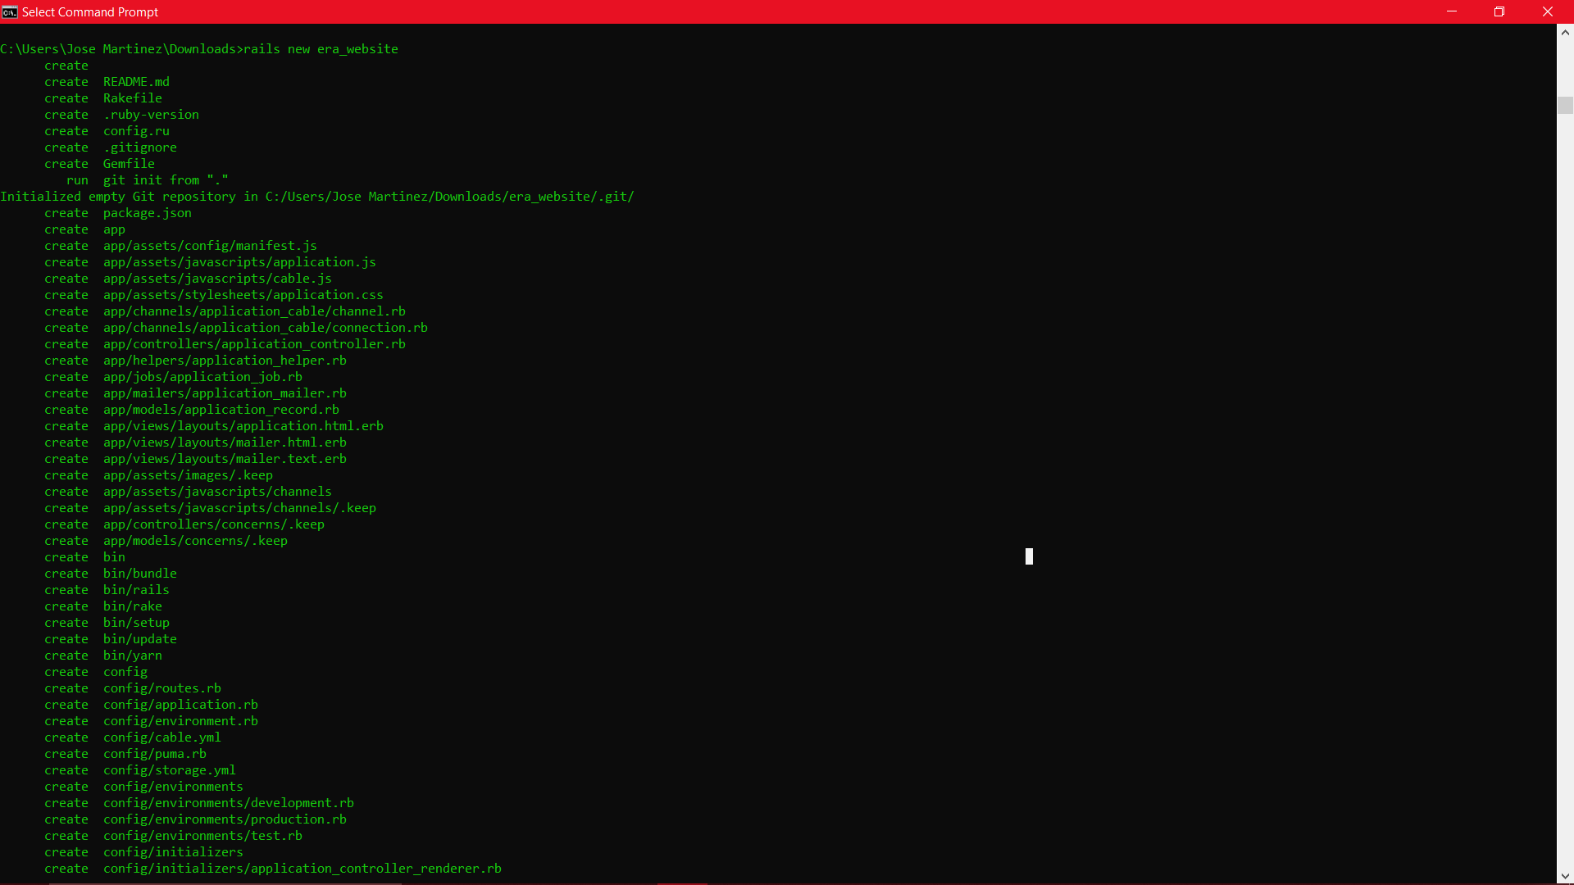

Generating the controller for the welcome page and index action.

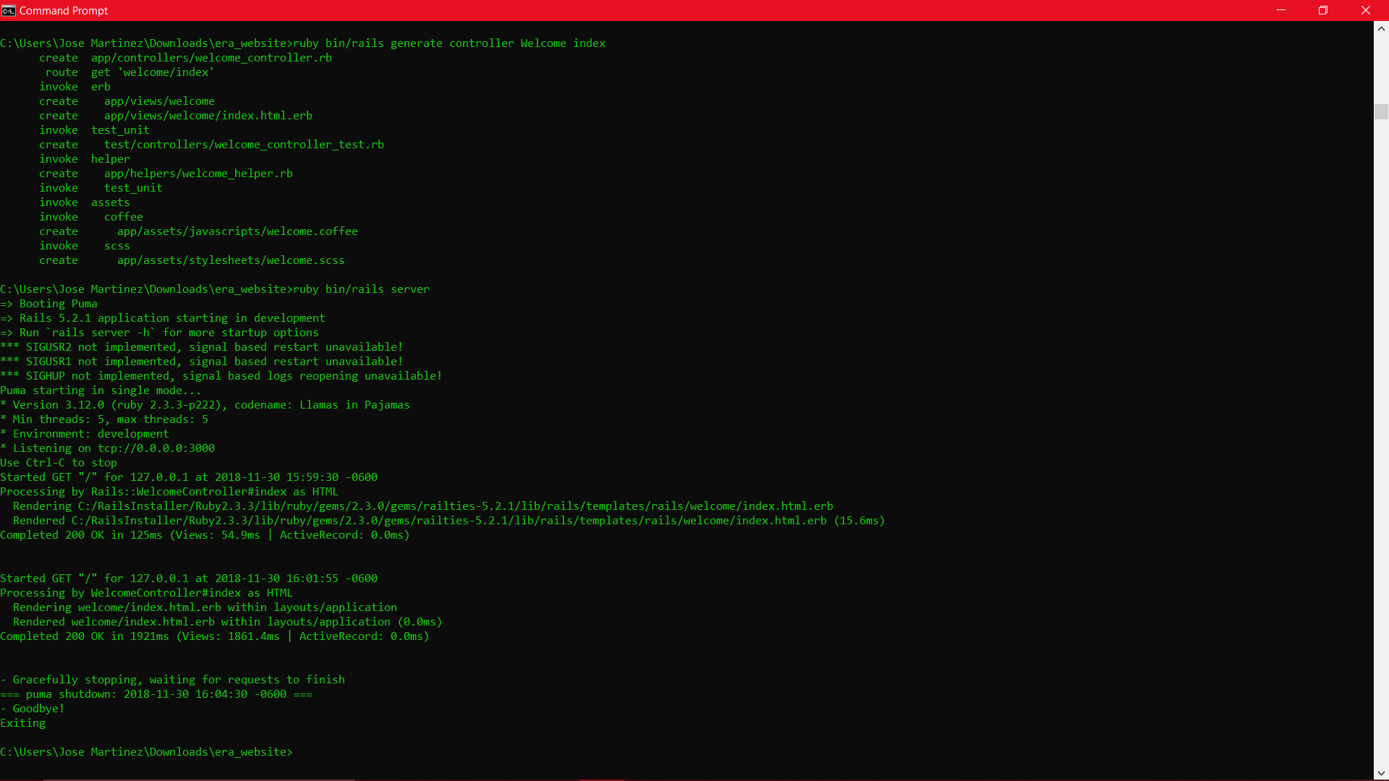

Creating the disasters model 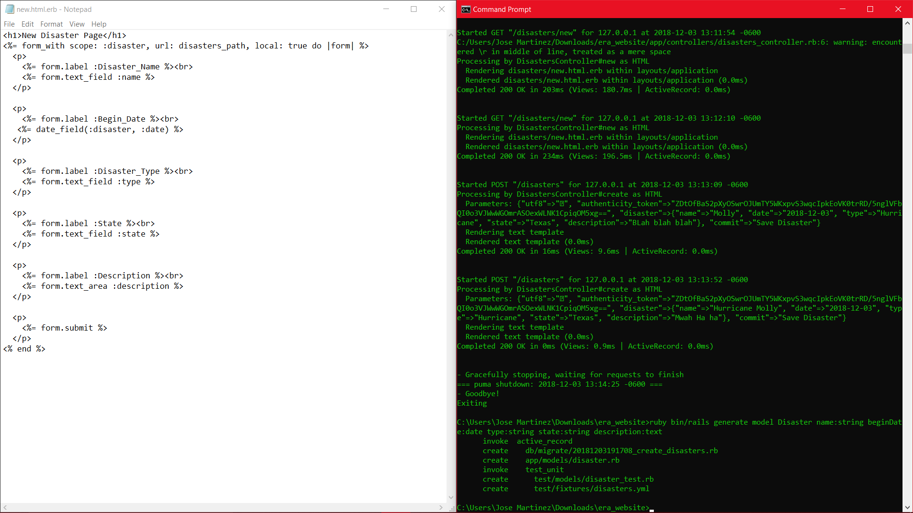

Creating the Supply model

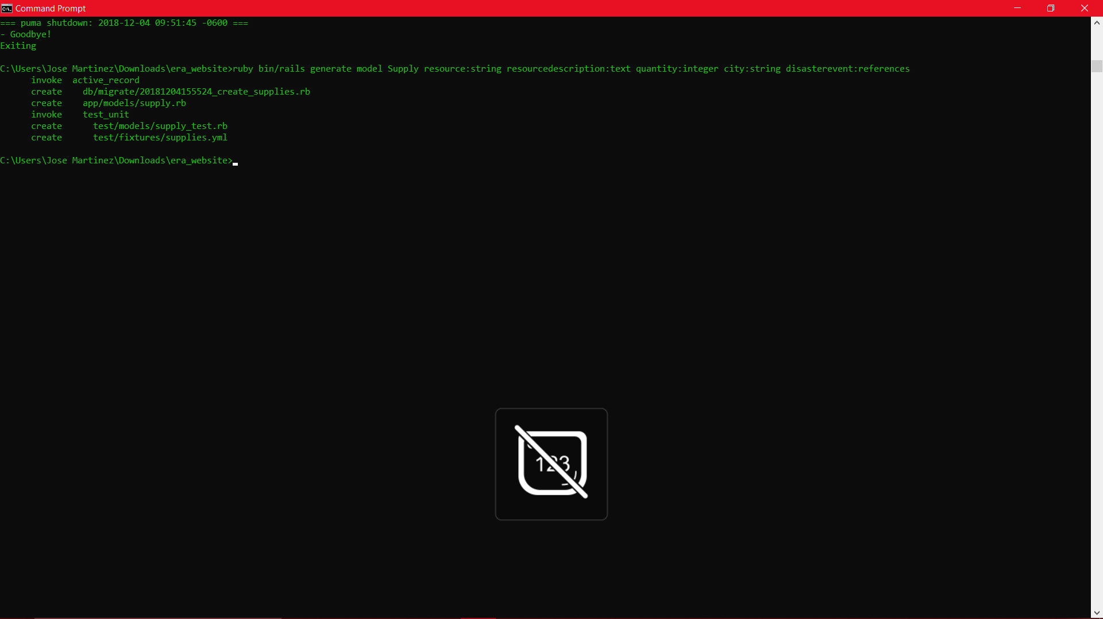

Running the migration for the supply model

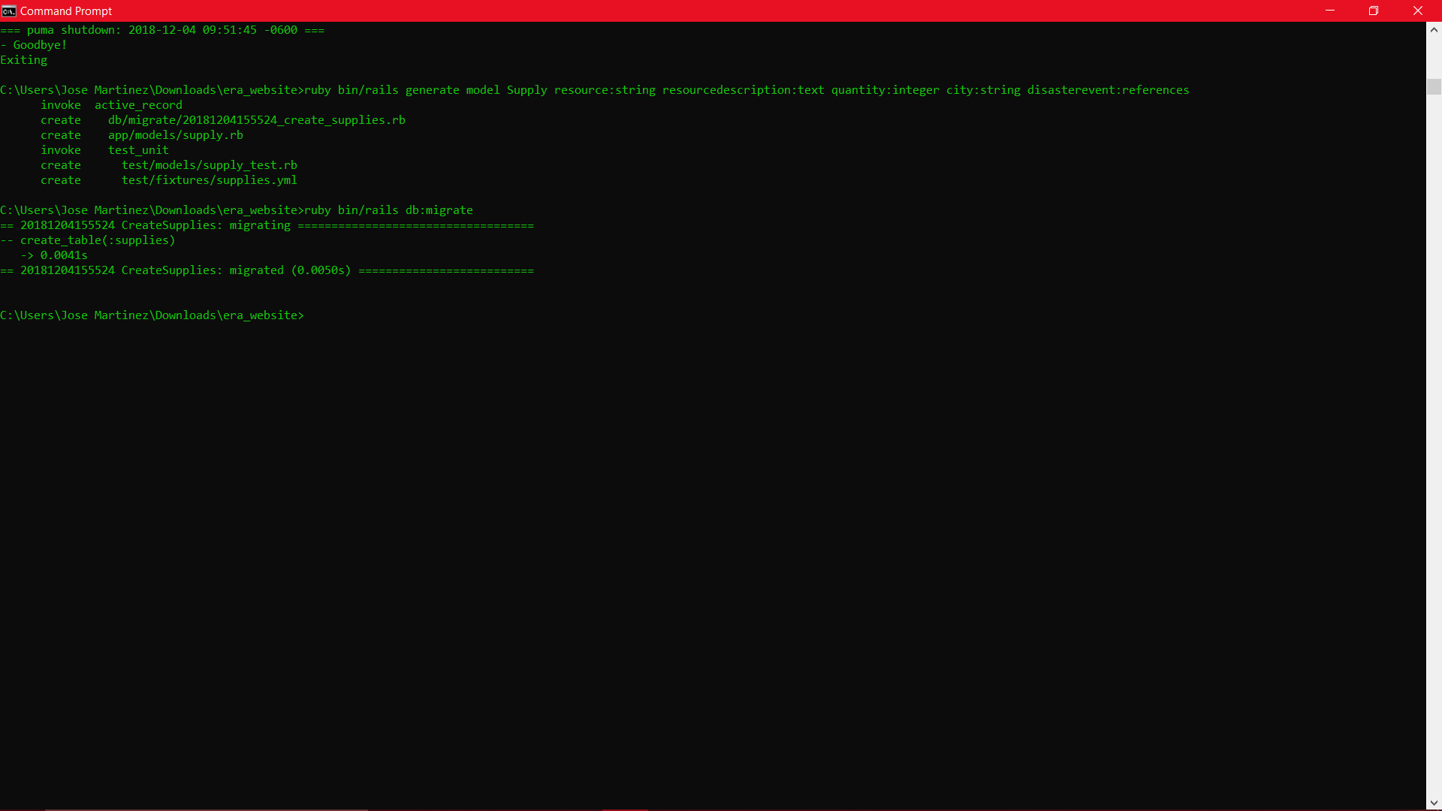

Generating the Resourceitem model, replacing the supply model

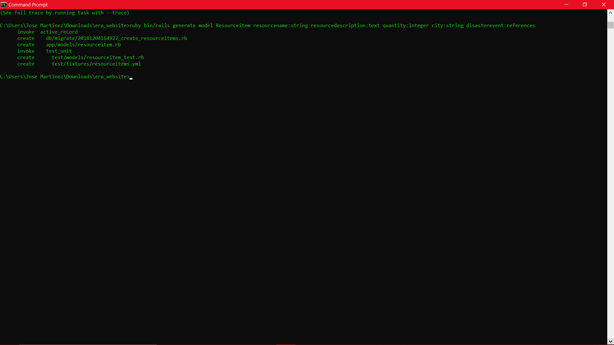

Migrating database for resourceitem

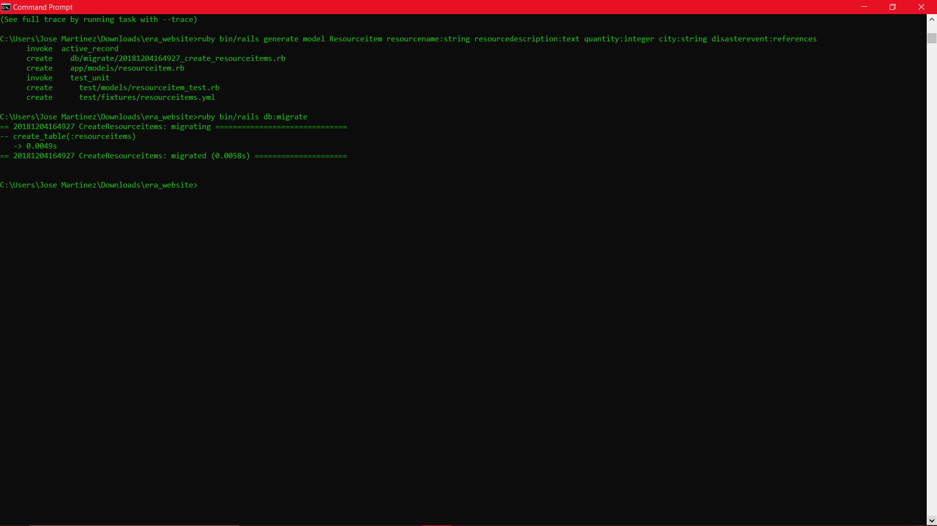

Creating controller for resourceitems

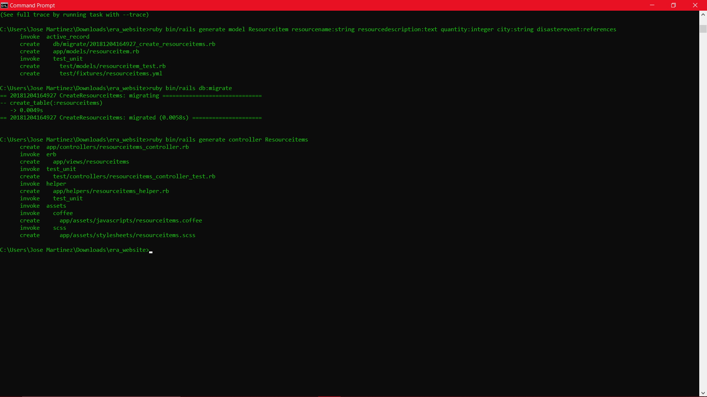

Generating controller for Govtusers

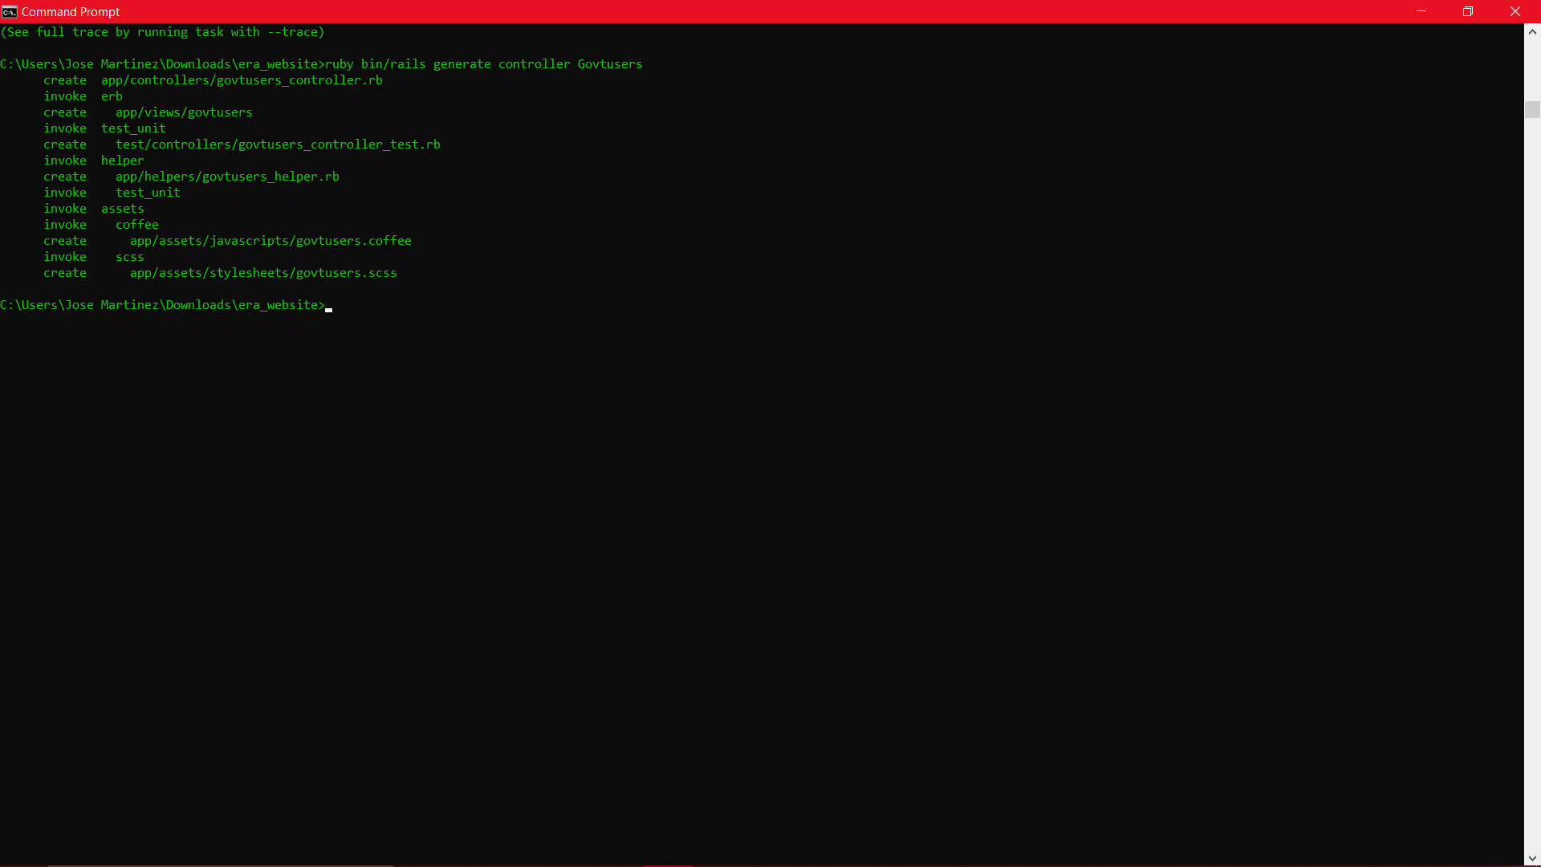

Generating model for Govtuser

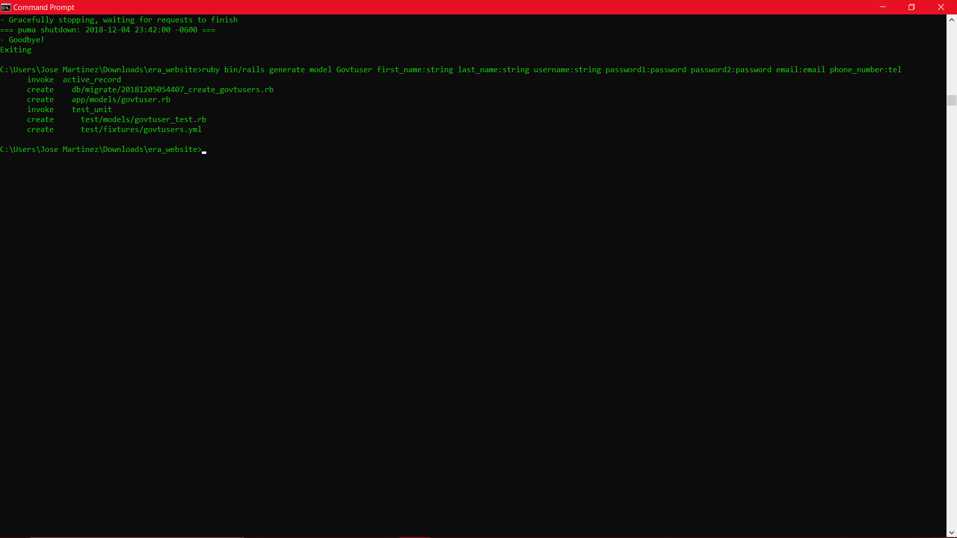

Fixing some type errors and regenerating model

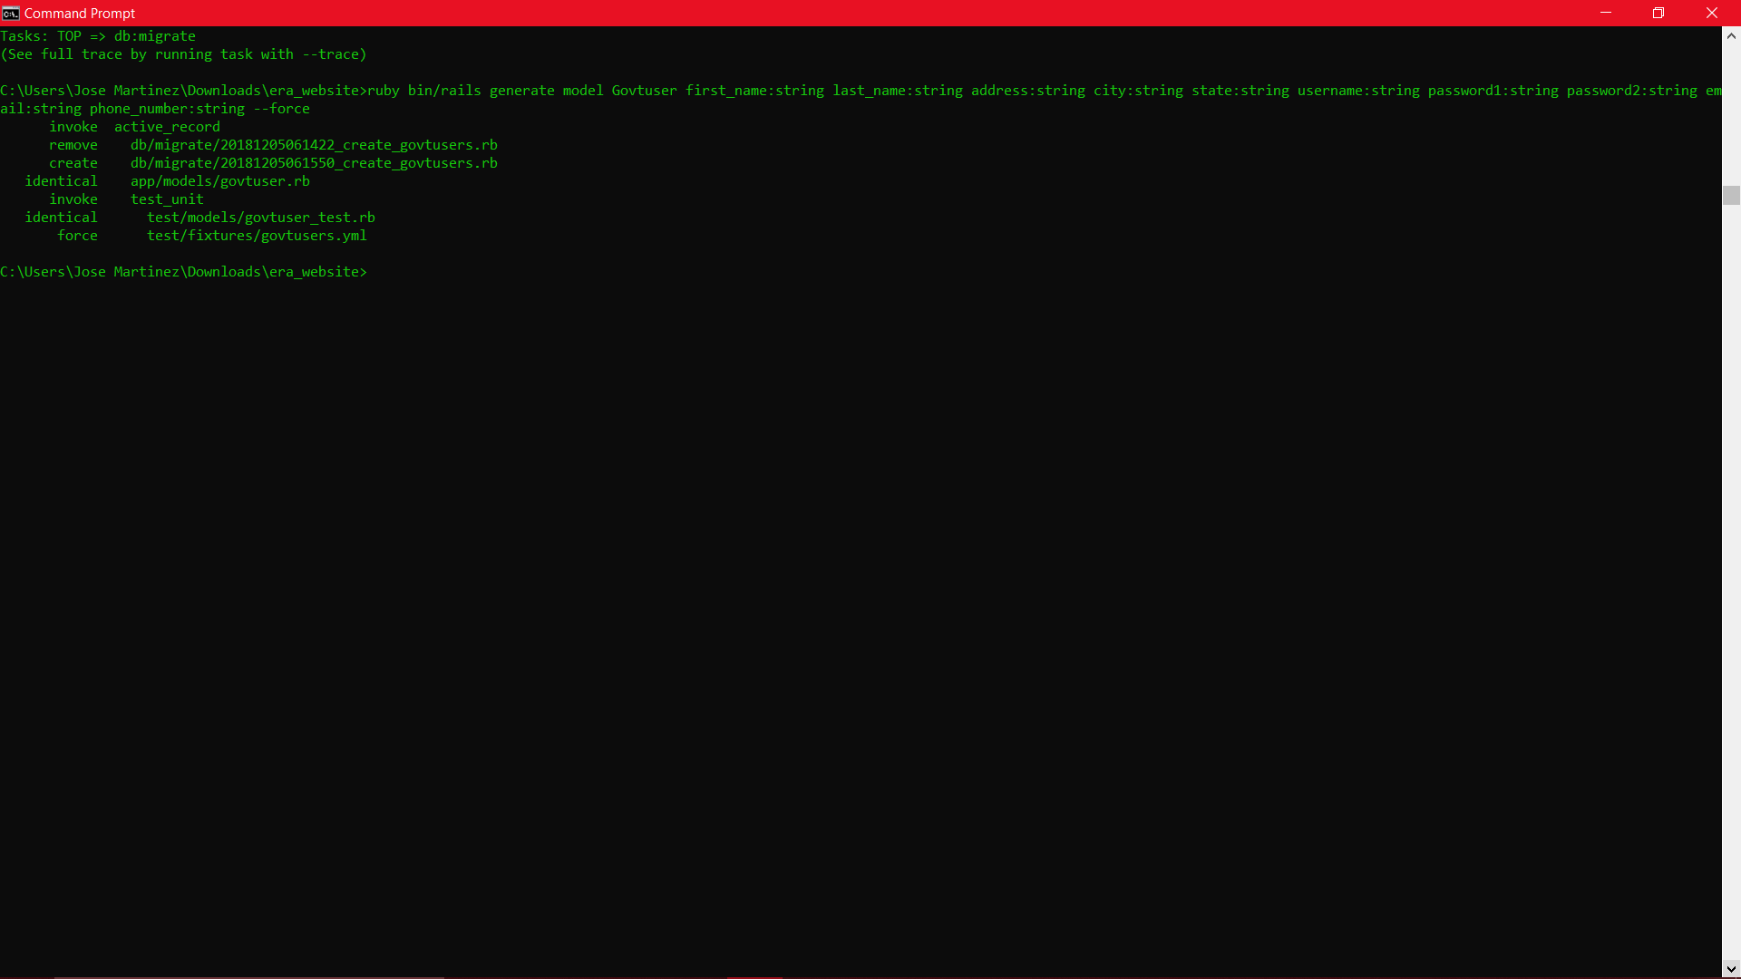

Generating the civilian users controller

